Project Report Template

1. Introduction

1.1 Overview

House price prediction in a metropolitan city in India is a valuable solution for potential home buyers, real estate agents, and inventors. By leveraging historical sales data, property details, and location-specific information, a predictive model can accurately estimate house prices. The model’s scalanility, real-time updates, user-friendly interface, and transparency ensure it meets the needs of stakeholders. Integration capability, data privacy, and cost-effectiveness are also important considerations. By addressing these requirements, the prediction model provides reliable insights,empowering stakeholders to make informed decidions in the fast-paced real estate market.

* 1. Purpose

Prediction house prices are expected to help people who plan to buy a house so they can know the price range in the future, then they can plan their finance well. In addition, house price predictions are also beneficial for property investors to know the trend of housing prices in a certain location.

1. problem definition & design thinking

2.1 Empathy map

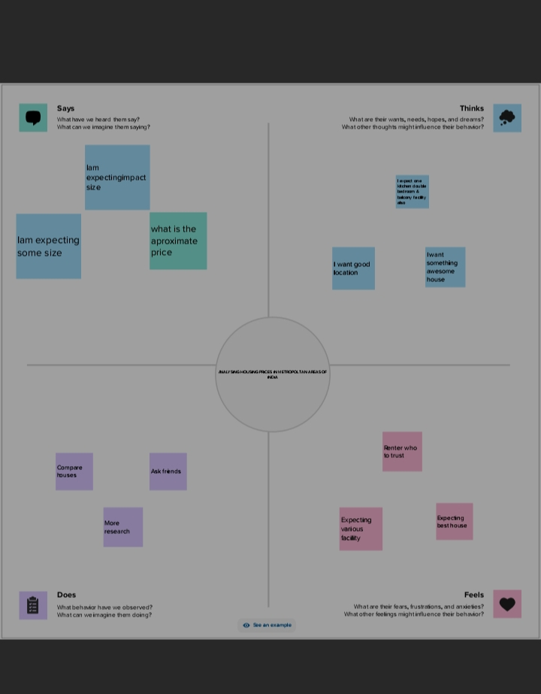

* 1. Brainstorming Bridge

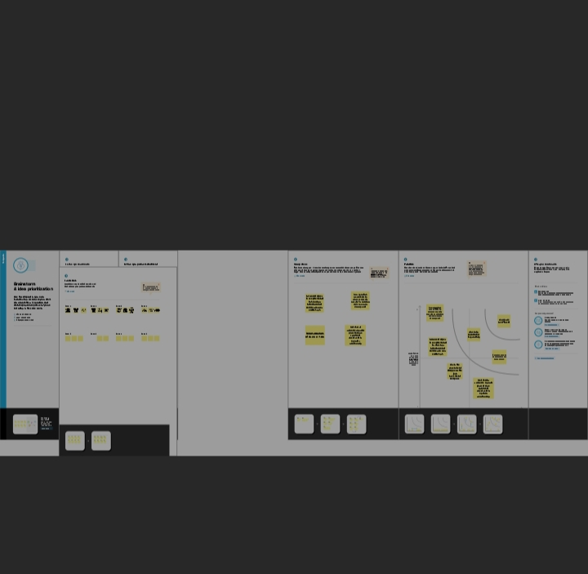

In this map shows the latitude and longitude based on the location

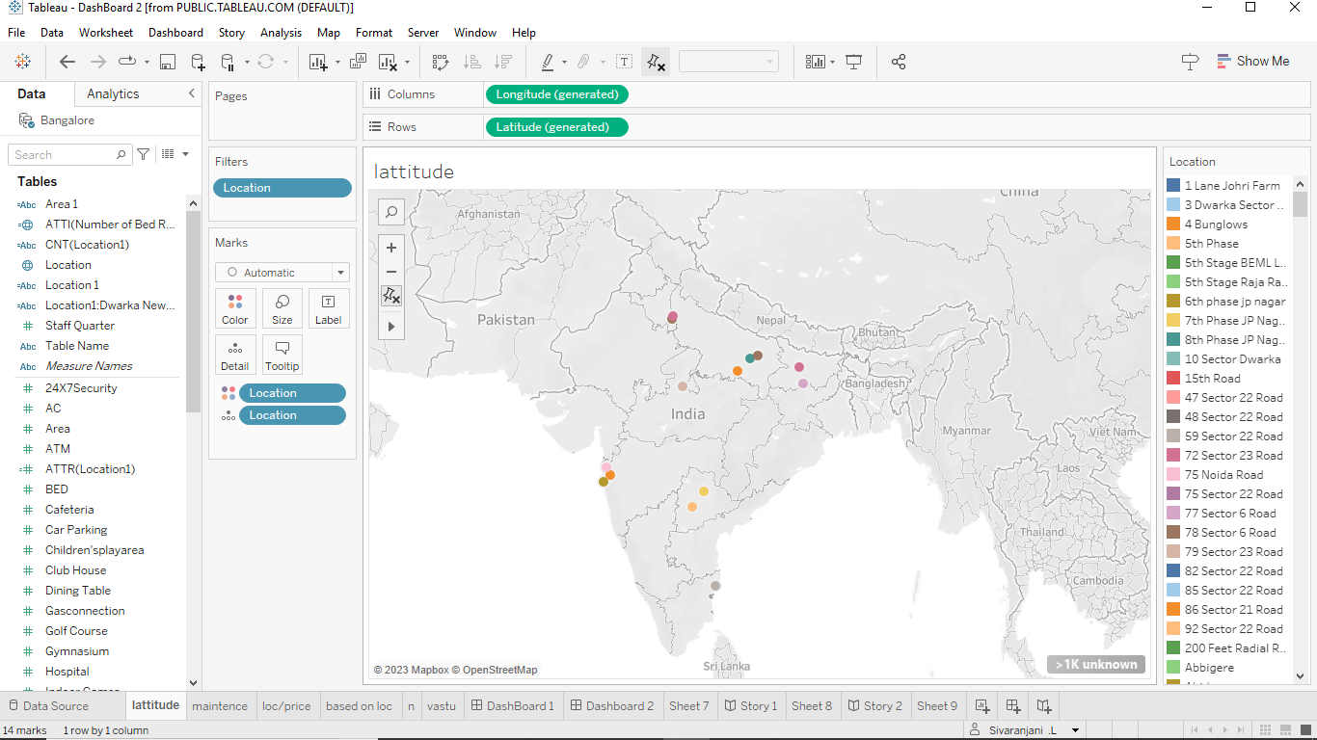

In the piechart shows that Maintainstaff in house prices

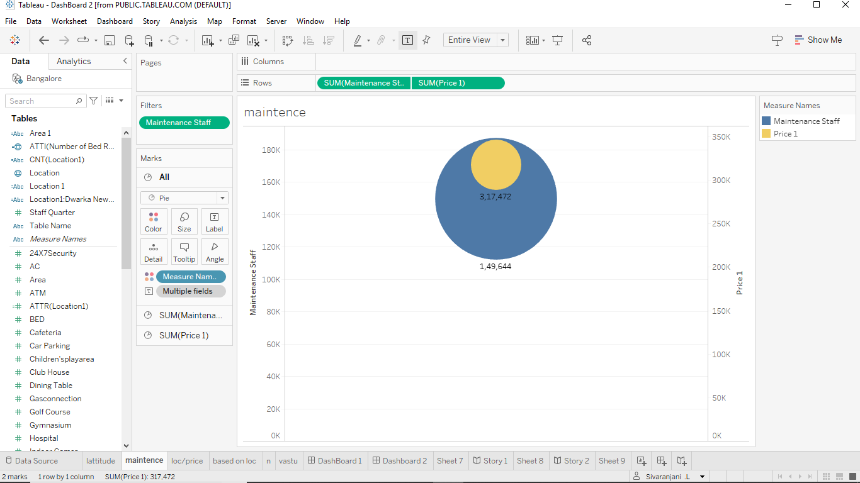

In this bar diagram shows that House price based Number

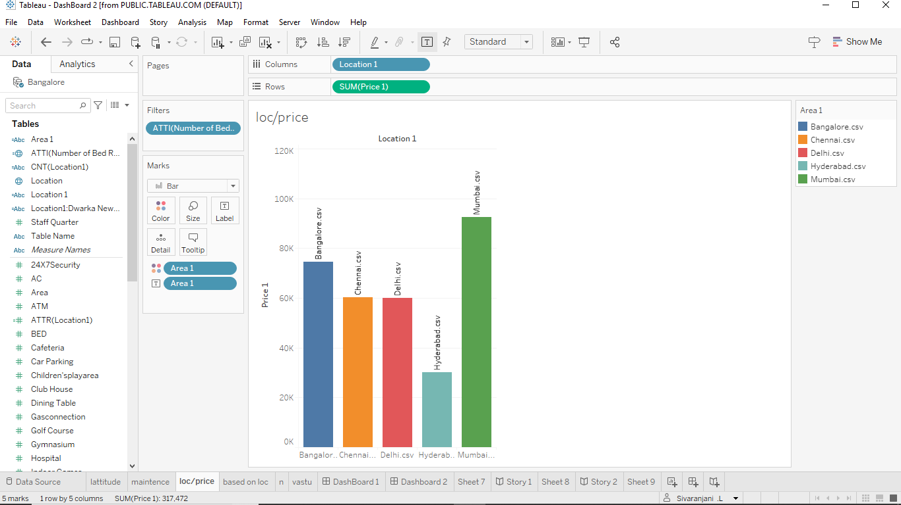

In this pie chart shows that All service Based on Location

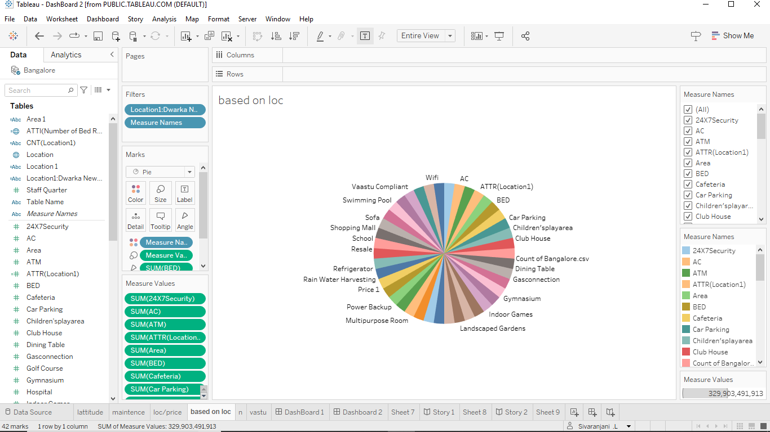

In this Bar diagram shows that Vastu-complaints based on

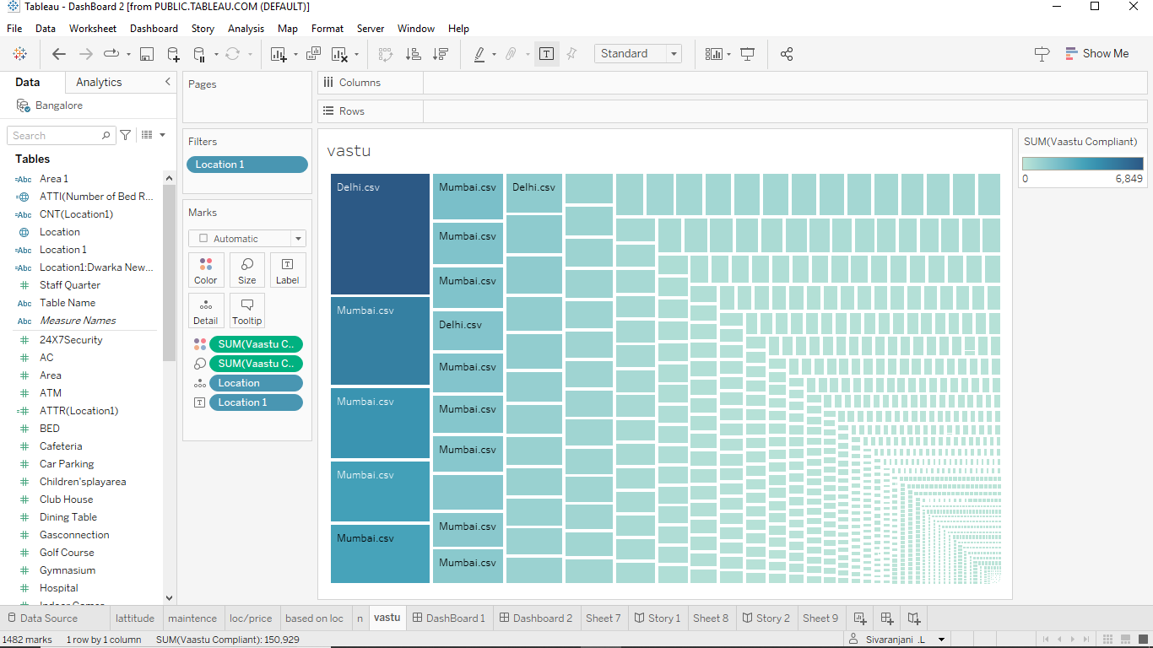

4. Advantages

a. Creative solutions job creations.

b. More profitable outcomes.

c. Improve the communication.

d. Holistic approaches and shared finding of solutions.

e. Promoting change.

5. Disadvantages

1. Financial losses can occur.
2. Power and status difference between the partners.
3. Intra and inter organizational conflicts.
4. Difficulty in merging institutional values and cultures.
5. Non-compatible.

6. Conclusion

In this story we will represent the visualizations are,

1. Latitude and longitude based on location.
2. Number of house based on area in sqf.
3. Houses price based on rainwater harvest pits.
4. Vastu-Complains Based on location.
5. House price based on number of bedrooms.
6. Hospitals and schools near the houses.
7. Maintains staff in house price.
8. House price and intercome
9. All service based on location